Redux Mobile allows creating substances from materials directly in Unity.
This has 2 main advantages:
- Substances are much smaller than bitmap, you can thus reduce the size of your download package.
- Get dynamic parameters to play with your materials both in Editor and at runtime.

Substances work on the following platforms:
- Windows Desktop
- Mac OSX Desktop
- iOS
- Android

For more information about substances in Unity, go and check the documentation here: http://docs.unity3d.com/Documentation/Manual/ProceduralMaterials.html

You can either chose to transform a material into a Substance from the Project
panel, or transform and replace all materials in your scene at once.

Redux a material

To transform a material into a substance, right-click on your material in the Project panel and chose Redux It.

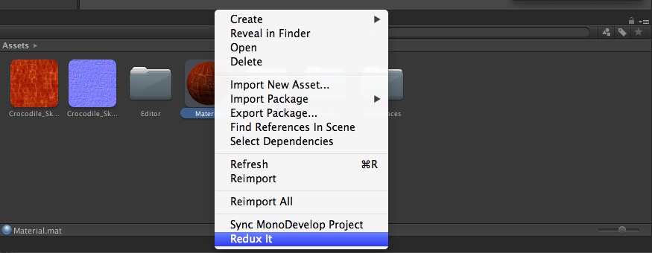

This will create the following files:
- A material, called “MaterialName_reduxed”
- A Substances folder, containing the new substances created

You can now assign the new MaterialName_reduxed on your mesh, and change its properties in the substance file.

Redux Menu

Redux all materials in the scene: This will create a substance for each material in the scene.
Delete All Materials Redux: This deletes all the substance materials created with Redux in the scene.
Update Materials: You should use it after using Redux all materials, in order to replace all the materials by substances in the scene
Revert Update Materials: This reverts all the substance materials to the original materials.
Change Filter: You can change the filter and use your own substance filter. This can be for example very useful with Bitmap2Material to apply it on all your assets automatically!

If you have any questions, go to forum.allegorithmic.com or contact us from our website: http://www.allegorithmic.com

